**Book-A-Study Room**

**Deliverable #3**

October 4th, 2018

**HAXORS**

Eliza Gaudio (1554032)

Elie Sader (6128748)

Jonnie Klein Quezada (1640380)

Kevin Hirsh (1634710)

Kyle Nancoo (1441915)

**Client organization:**

Vanier College Library

**Client name:**

Haritos Kavallos

**Table of Contents**

Executive Overview…………………………………………… 3-4

Summary description of client...……..……………………. 4-5

Business problem………………………........................... 5-6

Description of information system……………..……….... 6-8

Appendix 1……….………………………………………………... 8

Appendix 2………………………………………………..……….. 9

Appendix 3….………………………………………….….. 10-11

Appendix 4…………………….……..…………………………. 12

Appendix 5…………………….……..…………………………. 12

Appendix 6…………………….……..……………………. 13-15

Bibliography…………………………………………………….. 16

**Executive Overview**

In this document, you can find quite a few interesting pieces of information regarding use cases and UML diagrams.

Our client is Haritos Kavallos, manager of the Vanier College Library. Under the “Summary description of client” section, you learn quite a bit about Haritos’ academic/work background, based on information we found out about him by asking and getting into discussions with him about his life and accomplishments. We wanted to get to know our client, mostly because we will be working with him until the end of the semester, and it’s nice to get to know people on a personal level when you’ll be partnered up for so long.

We discovered quite a few business problems with our organization, some of which we could create a prototype for (i.e. the booking room system), and some of which we cannot solve. The primary business problem that we will be working to solve with our prototype is to allow the school to have an actual booking system for the students to book their study rooms ahead of time, and have a more organized system for the library. As it is right now, students are on a first-come-first-serve basis, and we want to implement a system that will change that, and allow the students to plan ahead of time.

The current information system in place is very simple. In this deliverable, under the “Description of information system” section, you can find an in detail description of the process being used by the library at the present moment, and the diagrams that follow in the appendices outline that in a more creative way.

In Appendix 1, you can see that there’s a system diagram that was created to represent the current information system that’s in place for the library, where a student goes up to the librarian, requests to book a room, has their ID card scanned, and then proceeds to get a key for the room. Upon leaving, they must return the key to the librarian, and they get their ID card scanned.

In Appendix 2, you can find case templates for the study rooms, with the explanation of the process in detail. We only have 2 use cases. One case describes the process of requesting a room and booking it, and another case describes the process of leaving the room and signing out.

In Appendix 3, there are 2 sequence and 2 activity diagrams that each represent one of the use cases created for the library study rooms. In case template 1, we talk about the process of booking a room. Sequence diagram #1 and activity diagram #1 are in relation to the events that occur for booking a room. Case template #2 is about leaving the study room, and what happens when a student is done using the specific room. Sequence diagram #2 and activity diagram #2 is related to that.

In Appendix 4, you can see a statechart diagram for the process of booking a room. It includes details about what happens if the rooms are misused, what happens when you book one, etc.

In Appendix 5, you can find a copy of a class diagram that represents the entire information system currently in place for the Vanier library. In this class diagram, it outlines how a student goes to see a librarian to request a room, and they have the option of booking 5 different rooms, 4 of which are study rooms, and one of which is a music room.

In Appendix 6, we have a copy of the documents that the client uses when a study room is booked by a student. Basically, the document states the policies and rules to follow when using the study rooms, and it lists a bunch of rules that the students must follow when using the rooms. The student has to sign the document in agreement and return it to the librarian.

**Summary description of client**

Our client goes by the name of Haritos Kavallos. He works at Vanier College, the institution/organization where our library booking rooms are. Haritos has accomplished quite a long list of things in such a short period of time; his CV is extremely diversified. He’s studied in many different programs, as well as been employed at many different places/positions.

To vaguely summarize Haritos’ educational/career background, he started college in 2004 and completed his DEC in Computer Science Technology in 2008. Following that, from 2008 – 2017, he spent 9 years studying to get a computer science degree, an educational degree, and a business degree. He is currently still in school at McGill, further pursuing a communications degree. He has worked as a software developer, a teaching assistant, and a tutor, all in different academic institutes. He is now currently the Learning Commons coordinator at Vanier College, which includes departments such as the library, the Tutoring and Academic Success Centre and the Science, Technology, Engineering and Mathematics Centre. He is responsible for any planning, organizing, coordination, supervision and evaluation concerning those departments.

We are working alongside him to develop our prototype system for the library’s booking rooms. The librarians keep track of information regarding the rooms, but Haritos is the manager who has all the access, so we deal with him primarily.

**Business problem**

As established previously, the students who wish to book a study room are not allowed to book that room in advance. So, for example, if a student knows they have an exam in 2 weeks from today, and they want to have sufficient time to plan study sessions, they are not able to do so, because they can’t book themselves a study room weeks prior to that exam. They may only book a specific room the day of. So, in other words, if a student’s exam is on the 11th of October at 2pm, they can go see the librarians and book a study room on the 11th of October, as early as 7:45am, when they open, but no sooner than that day.

The process is as follows; a student would go up to the counter of the librarians, and the librarian scans their student ID card. They are then given a key to the specific booking room. The person whose ID was scanned is now in charge of going back to see the librarian to check out and give them the key.

The study rooms evidently get extremely busy around midterm/final season, and are typically busier in the afternoon, between 11am and 2pm. Not being able to book in advance is a big problem for some students, especially if they don’t anticipate not finding a room. A student can gather his/her group of friends and decide to go together to book one of the rooms for studying. They’ll have no way of knowing whether or not the room is booked, until they get there, and that’s an inconvenience, because then that group is stuck trying to find a back up plan to study for their exam.

A student who loves planning ahead won’t be able to. It’s also a problem for students who prefer studying in their academic environment, as opposed to at home. Some people get too distracted at home, and therefore prefer a library or their academic facility. Since the Vanier study rooms don’t offer advanced booking, and you won’t be able to know if the rooms are full before arriving there, it may lead to student frustration.

Teachers also run into problems with the study rooms, because sometimes, they like to use them for group projects/events with their students. For example, a teacher tells his/her students in his/her previous lecture that they will be doing a group activity. That teacher intends on going to book one of the study rooms. They’ll attempt to ask the librarians, or the staff in charge of the bookings, if they could guarantee them a spot, but they can’t. The teacher then takes a risk by going up to the room with his/her students, and could possibly face the challenge of having all the rooms booked. At that point, they’re stuck trying to find somewhere else to go, and that’s another inconvenience for them.

It could also cause Vanier to have a lot of competition, because if a student could book a study room in another institution, like a library in their area, or another academic building that offers their rooms to any student that wants to book one, well Vanier then loses the opportunity to have their students use the services they provide.

Their process is a bit unorganized and inconvenient, and we believe that it would benefit the students, the teachers, as well as the staff, to implement a system that would allow people to book these study rooms ahead of time, and keep track of how many rooms are booked, during what time they are booked, and for how long they’re booked. The idea is to create a system that management, librarians, and support staff could access, to allow the students/teachers to book in advance, and to let the staff see the activity happening with their booking rooms. All those things, and more, would facilitate the lives of students, teachers and staff.

**Description of information system**

The current system that’s in place is not very complex. In order to book a study room at Vanier, the process is very simple. The students require having a valid student ID, and that’s pretty much it. The way it works is that one single student from a group of minimum 3 people will go see a librarian and request to book a study room. They may not book days in advance, but only day of. They ask for available rooms, and if one is free, the librarian will scan that person’s ID, have the group fill out the form, and will then proceed to give them the key to the specific room. The students may then go use their study room for the maximum allotted time of 3 hours. After that, the student whose ID was scanned must go sign out with the librarian and return the key, otherwise could be charged a fee.

Appendix 1 has the system diagram that outlines everything that was just mentioned in the above paragraph. In this diagram design, you can see the functionality of the process, and how each previous step relates to one another. The diagram begins by showing the student requesting a study room from a librarian. The librarian will start by verifying if there are any rooms available, and will then proceed to take the student’s valid ID to check them in, and give them a key. Following that, the student and his/her group will go into the study room and fulfill their purpose. Upon leaving the room, they head back to the librarian, they return the key, they check out, and the process is over.

Appendix 2 contains the use case templates for our Vanier library study rooms. A use case is a list of event steps used when trying to develop a software/prototype. A lot of programmers and business developers use them to be organized. Our first use case template describes the process of booking the actual room. A student must go see someone at the library to request the room, where they are then asked to fill out an agreement form, upon the vacancy of any of the 4 study rooms, or the single music room. The second case template is the process of leaving the room, where the student has to go back to the librarian to sign out and return the key, or will be fined a fee.

Appendix 3 is the representation of the case templates in diagrams. For each template, there is one sequence and one activity diagram, each illustrating their specific template. A sequence diagram represents object collaboration, whereas an activity diagram represents the dynamic aspects of a use case. For case template #1, where we talk about the process of booking a study room, you have the sequence diagram that shows how each object/person that relates to the case connects with one another, and the activity diagram shows how one activity flows/connects to another. In case template 2, it’s the exact same concept, but this time, for the process of leaving the study room. The sequence diagram shows how each object/person connects, and the activity diagram outlines how each activity connects, but for the leaving process instead.

Appendix 4 is where the statechart diagram for the process of booking a room is represented. This diagram includes the details of booking a room, what happens when you’re granted a room, and what happens when you misuse the service of the room. For starters, you have the student who wishes to book a room. One of two things could happen, either the rooms are booked and they will have to come later on in the day to try again, or they will be granted permission to book a room because they aren’t all full. In the event they aren’t full and the student gets to book on the spot, then they have to fill out the permission form. After filling out the permission form, the student will then have their ID card scanned by the librarian, they’ll be given the key to the room, and they may proceed to the study room. A couple of conditions are attached to this event. If a student fails to comply with the rules of the study rooms, they will pay a fee that could be as large as $100. If they fail to check out, they get lead to the same fate. If all goes well, after finishing with the room, they scan their ID, return the key, and that’s the end of the process.

Appendix 5 is a class diagram that illustrates the process a student must follow in order to book the specific room they want. The library offers 5 different types of study rooms. Four of the rooms are regular study rooms, where you can enter the rooms and study as you wish with your friends. The fifth room is known as a music room, where you can go with your friend to listen to music and unwind. In the diagram, you can see a student going up to the librarian to book a room, where you then get the option to choose which room you want to book, all provided that it’s empty.

Appendix 6 shows a contract template that the students must read and sign before utilizing the study rooms. The client uses this form to ensure that the students are not taking advantage of the free service Vanier offers, and it also forces the students to understand that a potential fine could be charged if they misuse the rooms, or disobey the rules. Once they sign that form, they must return it to the one responsible.

**Appendix 1**

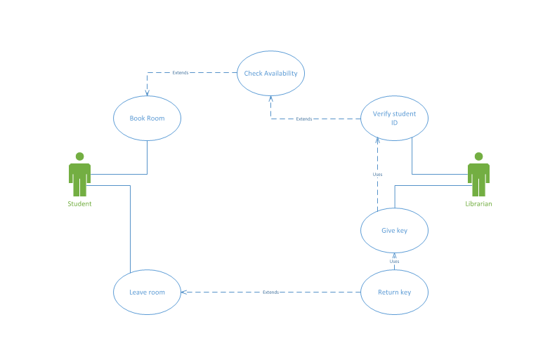

**Appendix 2**

**CASE 1:**

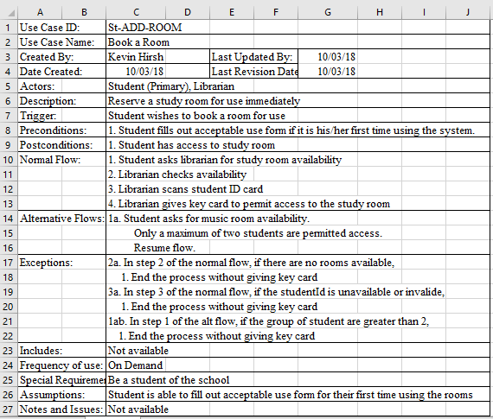

**CASE 2:**

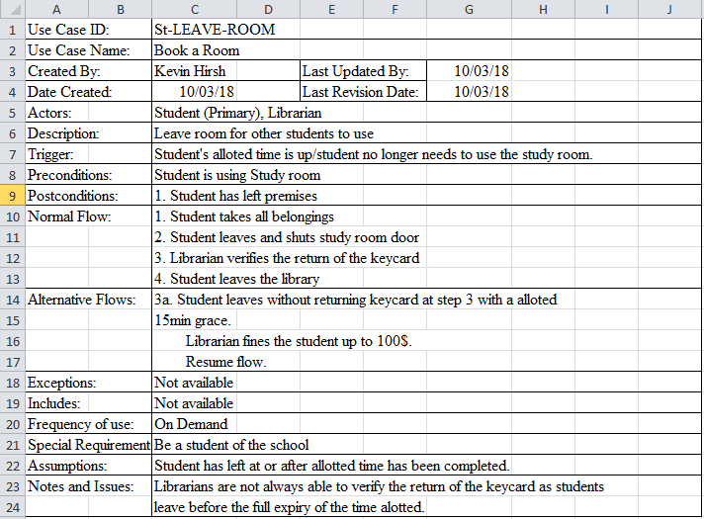

**Appendix 3**

**CASE 1 SEQUENCE DIAGRAM:**

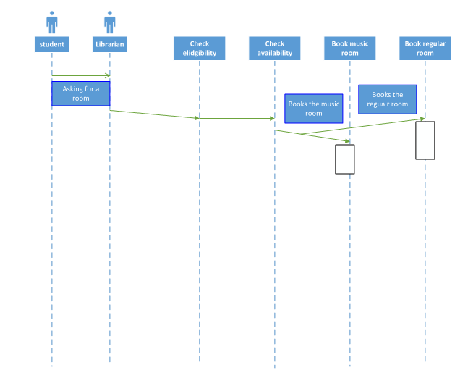

**CASE 1 ACTIVITY DIAGRAM:**

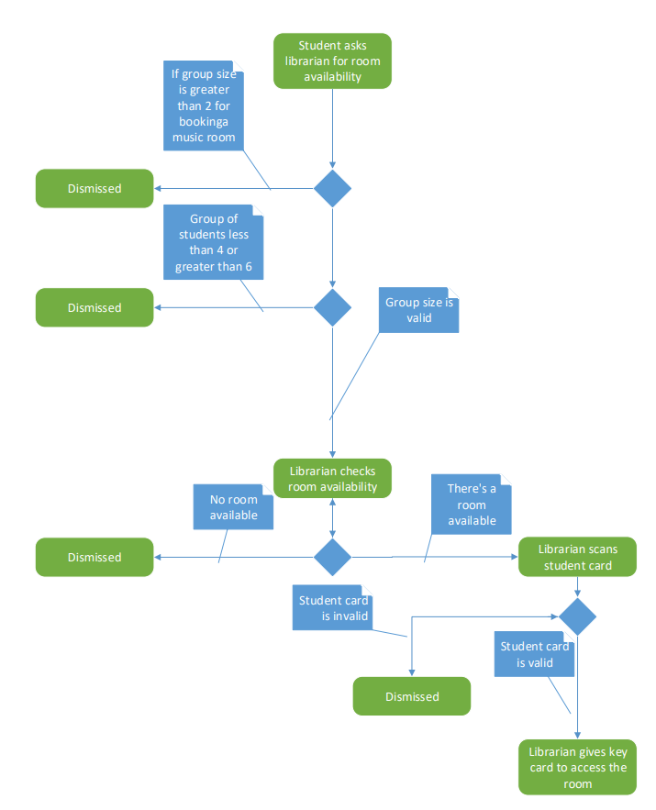

**CASE 2 SEQUENCE DIAGRAM:**

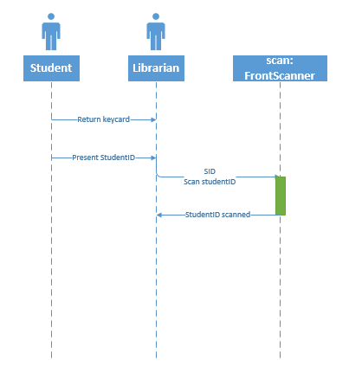

**CASE 2 ACTIVITY DIAGRAM:**

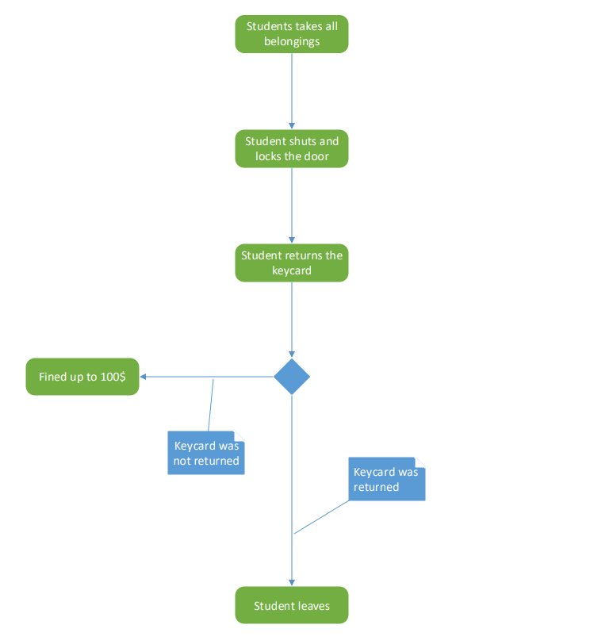

**Appendix 4**

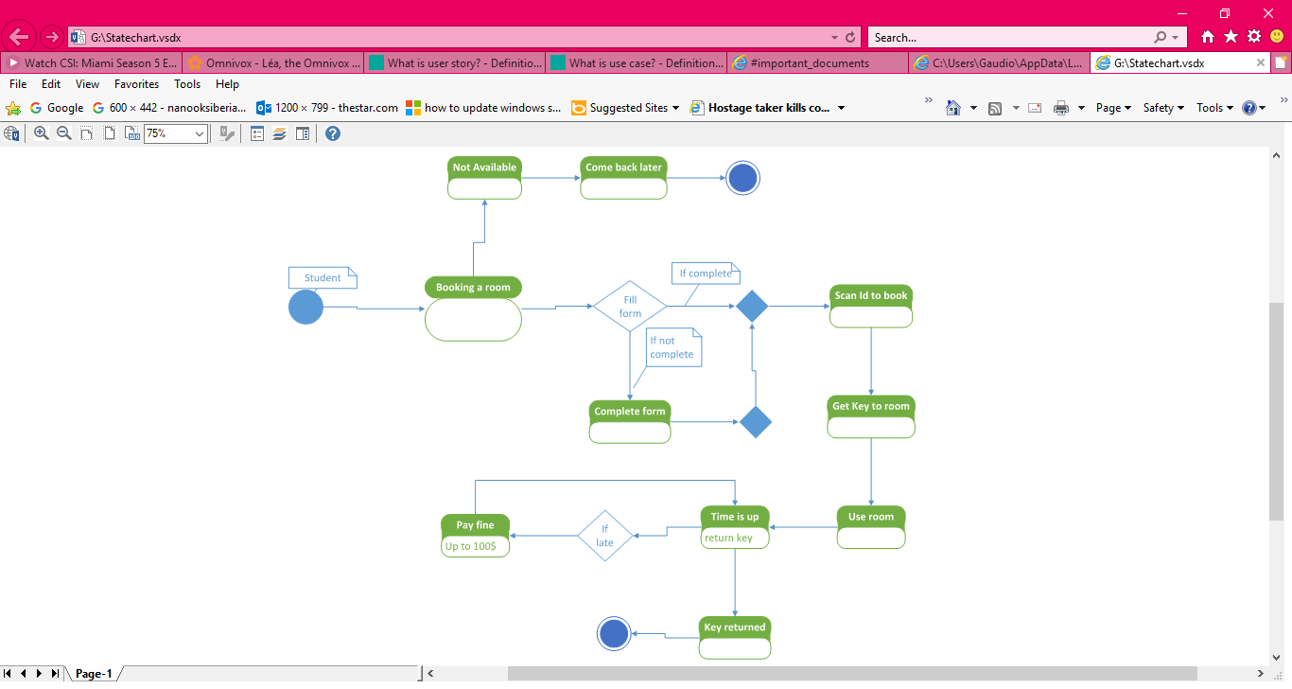

**Appendix 5**

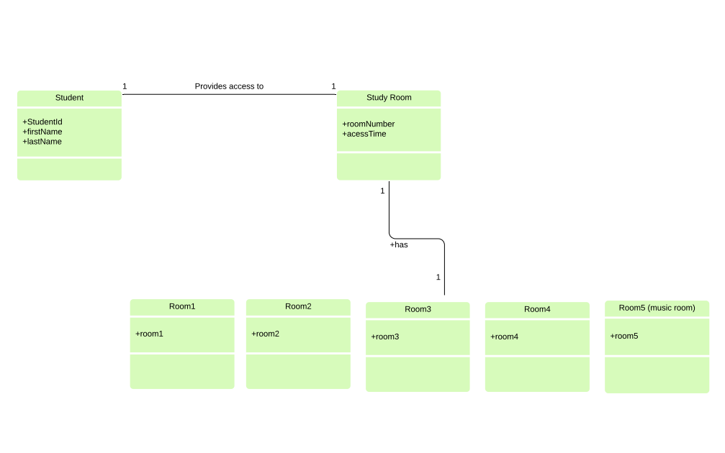

**Appendix 6**

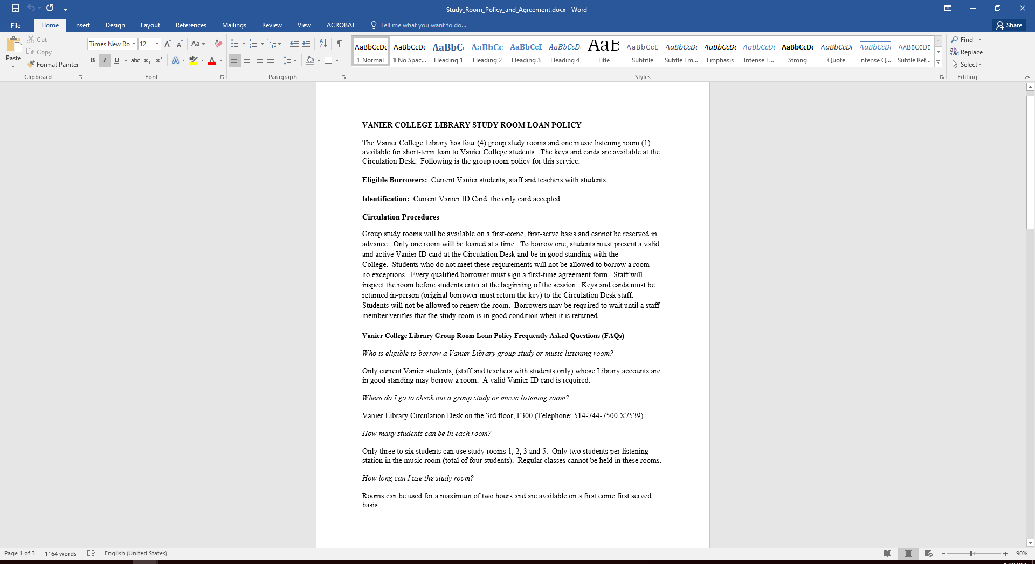

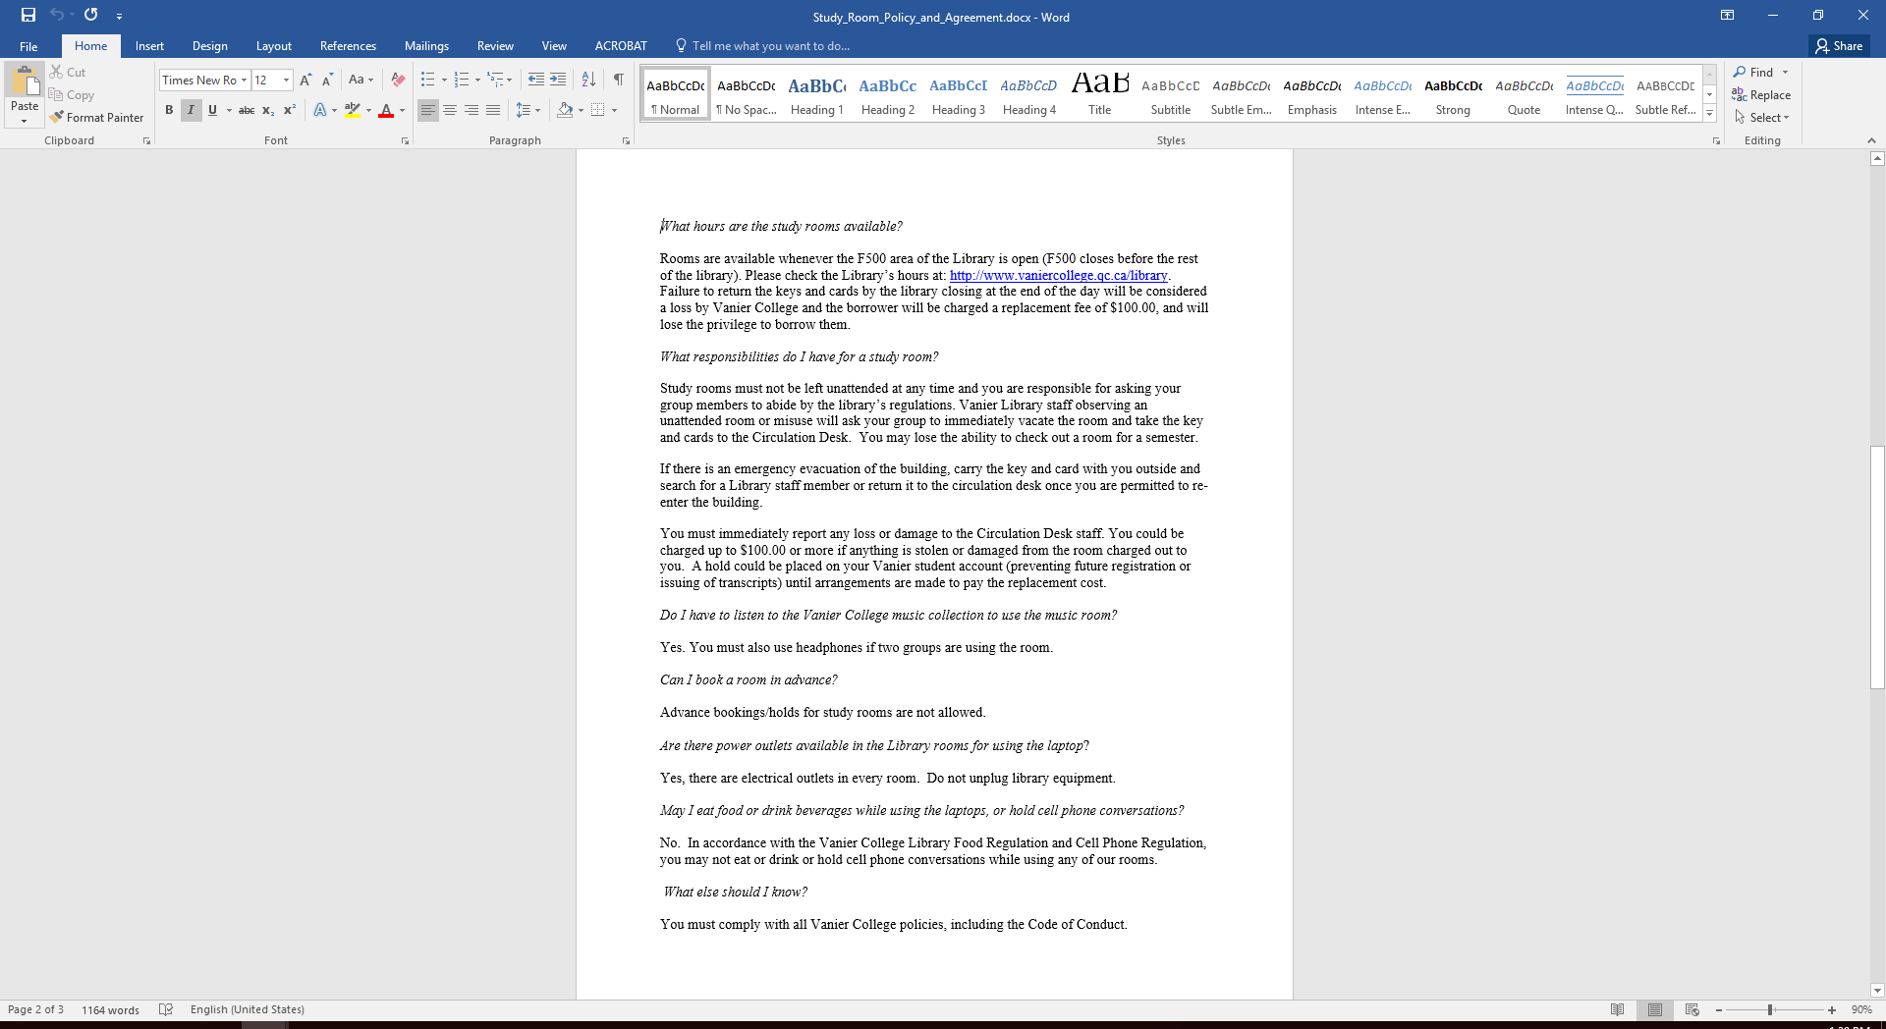

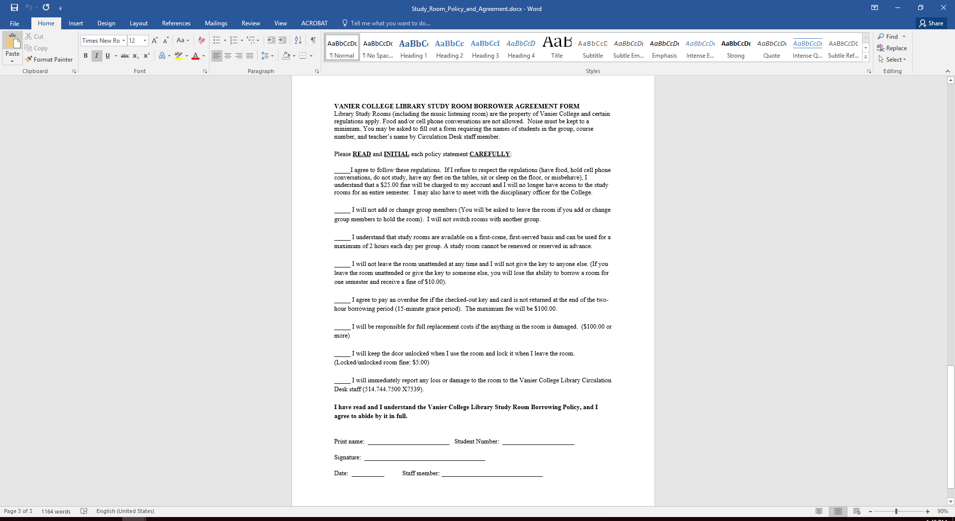

The screenshots above are from the specific document the client uses for the booking rooms. This document is not a document used to book the actual rooms, but rather a document of policies, and rules that the students have to follow when utilizing them. The student must be aware of these policies, as they are important to know if they want to be allowed in the rooms.

First time users must read and sign the borrowing agreement form, and give it back to the one in charge at the present moment of booking, understanding the rules, and not disobeying them.

**Works Cited**

* No references used in the process of writing this deliverable. N/A